

**Blog Generator**

**Website Design & Development**

**40201260**

**Y/618/7419**

**Section (3)**

**Submitted by**

Hamza AL-Risheq

**Submitted to**

Eng. Hana AlRasheed

**summer 2022 – 2023**

Table of Contents

Part 1: Website Goal: 3

1.1 Main goal of the website 3

1.2 Who is the website intended for? 4

1.3 What do customers/ users expect to find or do there? 4

1.4 - Is this website’s primary aim to inform, to sell (ecommerce, anyone?), or to provide a service? 4

Part 2: website scope: 4

Part 3: requirements: 4

Requirement 1: Engaging Home Page: 4

Requirement 2: Blog Display: 5

Requirement 3: User Registration: 5

Requirement 4: User Authentication: 5

Requirement 5: Insightful About Us Page: 5

Requirement 6: User Profile Management: 5

Requirement 7: Empowering Blog Creation: 5

Part 4: Sitemap: 6

Part 5: Wireframes: 7

5.1 Mobile wireframes 7

5.2 PC wireframes 11

5.3 Mobile Wireframe Elements 14

5.3.1 Login Mobile Page Wireframe Elements 14

5.3.2 Signup Mobile Page Wireframe Elements 14

5.3.3 Posted Blogs Mobile Page Wireframe Elements 15

5.3.4 Profile Mobile Page Wireframe Elements 16

5.3.5 Blog Setup Mobile Page Wireframe Elements 16

5.3.6 Home Mobile Page Wireframe Elements 17

5.3.7 About Us Mobile Page Wireframe Elements 18

5.4 PC Wireframe Elements 19

5.4.1 Login PC Page Wireframe Elements 19

5.4.2 Signup PC Page Wireframe Elements 20

5.4.3 Posted Blogs PC Page Wireframe Elements 20

5.4.4 Profile PC Page Wireframe Elements 21

5.4.5 Blog Setup PC Page Wireframe Elements 22

5.4.6 Home PC Page Wireframe Elements 23

5.4.7 About Us PC Page Wireframe Elements 23

Part 6: Launching: 24

# Part 1: Website Goal:

## 1.1 Main goal of the website

I outlined the aims of the blog in frank conversations with the relevant stakeholders. So, I found out that the goals are:

* Informing and educating readers about certain subjects, markets, or specialties by providing insightful knowledge.
* Positing the blog's owner or company as an authoritative and reliable source within a specific subject or business is known as thought leadership.
* Share ideas, opinions, and attitudes to influence debates and the opinions of readers on certain issues.
* Networking and Partnerships: Establishing connections with other bloggers, influencers, or companies in the same specialized market to cooperate and cross-promote.

So, mainly we can summarize the goal of the website is to create a place to share thoughts, ideas, theories, materials, teaching techniques, and so on.

## 1.2 Who is the website intended for?

The intended audience of a blog website is very wide. Here are some potential audiences that a blog website might target:

* Students and Educators.
* Explorers.
* Creative Professionals.
* Explorers.

## 1.3 What do customers/ users expect to find or do there?

The customers/users expect to find a place to write their own blogs, share it, and read other blogs (content sharing).

## 1.4 - Is this website’s primary aim to inform, to sell (ecommerce, anyone?), or to provide a service?

The website primary aim is to share information, and to inform.

# Part 2: website scope:

Customers will be able to quickly and simply produce high-quality blog content using the [Addition.com] blog generator. The generator will deliver a place for the users to write their blogs. Users may expect simple navigation and smooth user interaction, allowing them to quickly write and customize interesting blog content.

# Part 3: requirements:

## Requirement 1: Engaging Home Page:

The website's home page will act as an attractive introduction, presenting eye-catching graphics and thoughtfully written phrases that explain the numerous advantages of blogging. Users will also be able to easily engage with strategically placed buttons, providing smooth navigation to key pages like the About Us Page, Login Page, Blogs Page, and Ask for Help Page.

## Requirement 2: Blog Display:

Users will get access to a vast selection of insightful blogs that have been painstakingly posted on a special web page. Every blog post will be easily reachable, promoting an engaging reading experience.

## Requirement 3: User Registration:

Clients will have the option to establish personalized accounts on a dedicated Sign-up Page. Users will easily build their online identities through a simple registration procedure, opening up a world of customized services and interactions.

## Requirement 4: User Authentication:

By entering their assigned credentials on the Login Page, registered users will be able to easily access their accounts in a secure manner. This reliable authentication system guarantees confidentiality and exclusive access to customized features.

## Requirement 5: Insightful About Us Page:

Users may get a detailed look at the company's culture, beliefs, and mission on the About Us page. Clients will obtain a thorough knowledge of the organization's identity and mission through professionally created content.

## Requirement 6: User Profile Management:

Customers will have the freedom to manage their digital presence on their own terms using the profile symbol. Users may make changes to the information on their profiles using this feature, which makes it easy to edit, update, or delete information as needed.

## Requirement 7: Empowering Blog Creation:

The Blogs Page will include an icon that allows users to submit their own blogs, facilitating user-generated content. Users may write, customize, and share their ideas with the worldwide digital community through a seamless interface.

# Part 4: Sitemap:

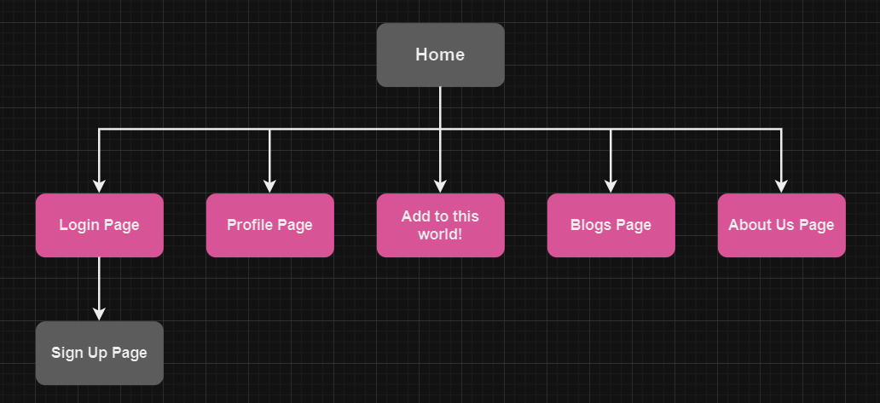

# Part 5: Wireframes:

## 5.1 Mobile wireframes

**Login Page Mobile Version. Sign-Up Page Mobile Version.**

**Blogs Page Mobile Version. Profile Page Mobile Version.**

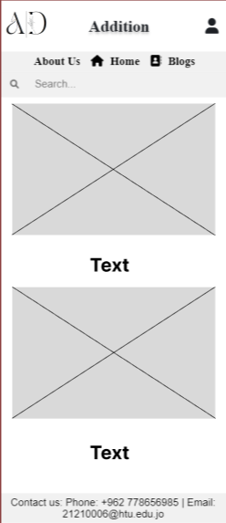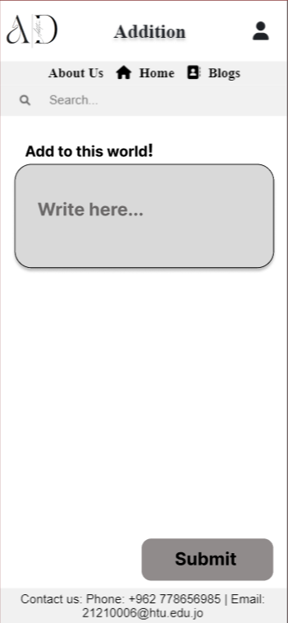

Blog StepUp Page Mobile Version. About Us Page Mobile Version.

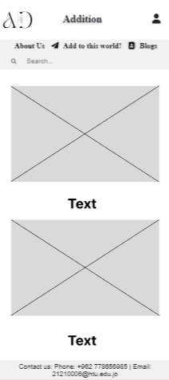

Home Page Mobile Version.

## 5.2 PC wireframes

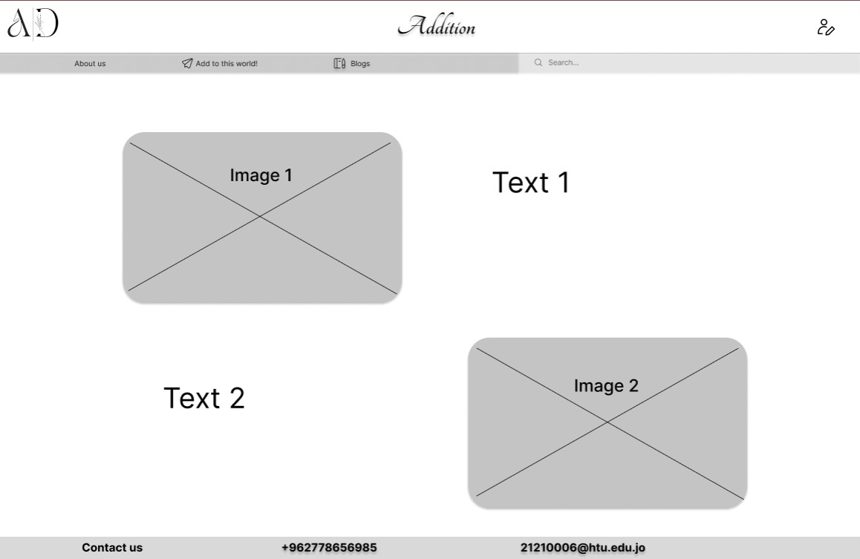

Home Page Pc Version.

Login Page Pc Version.

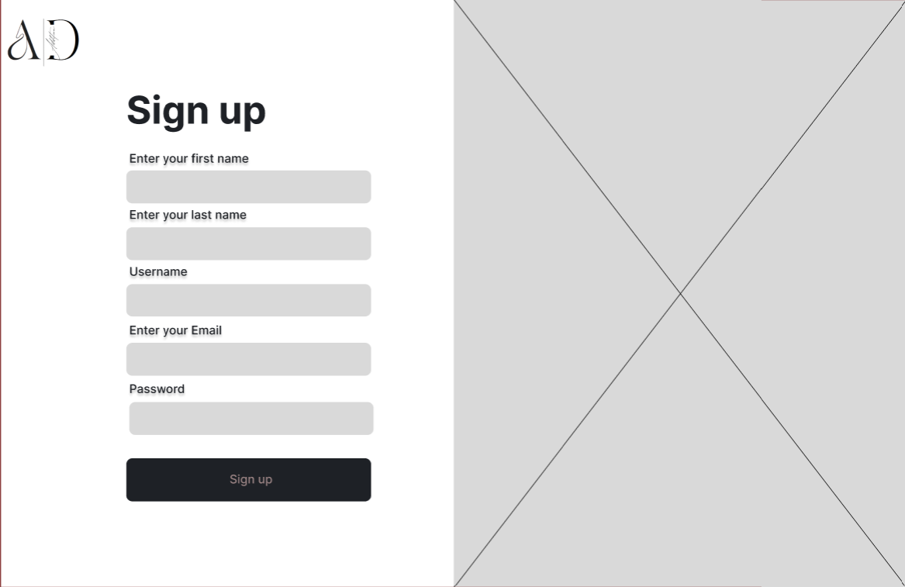 Signup Page Pc Version.

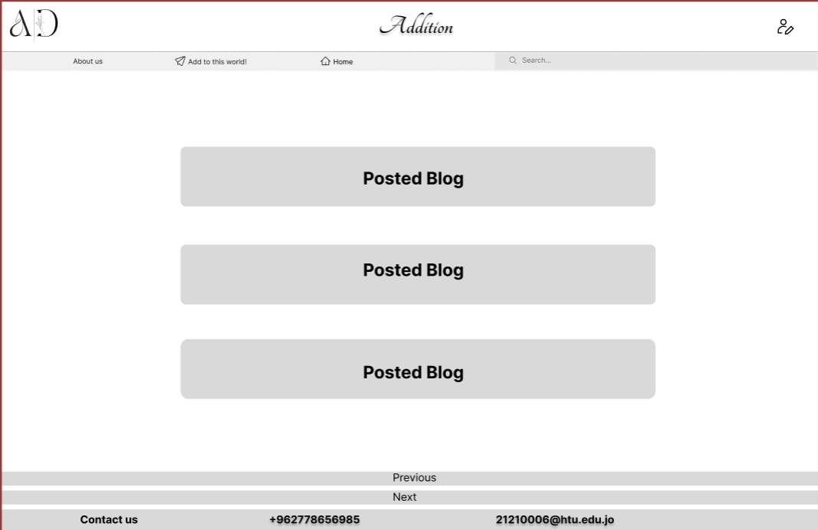

Posted Blogs Page Pc Version.

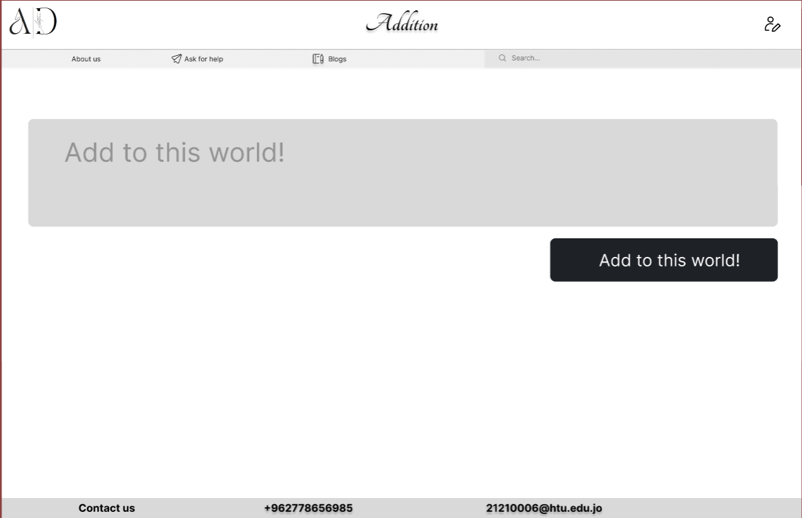

Blog StepUp Page Pc Version. 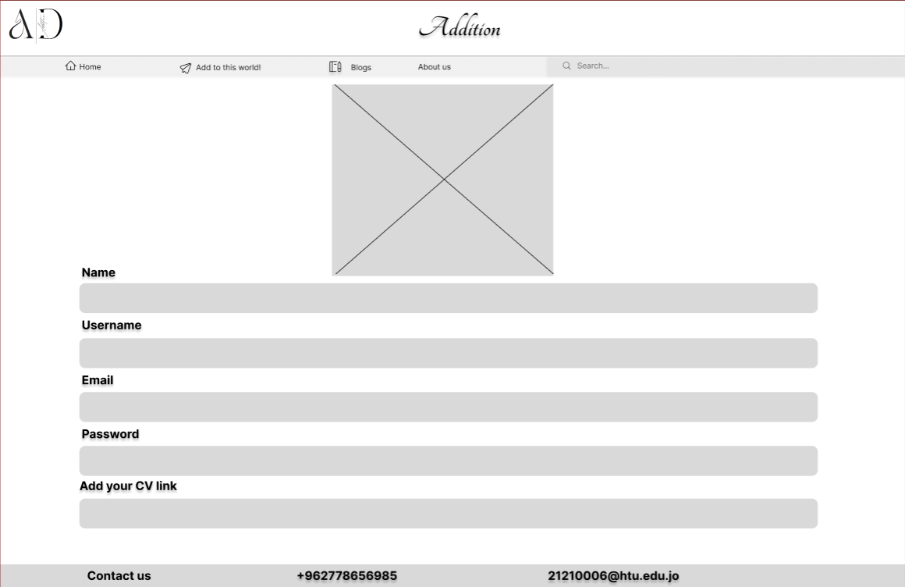

Profile Page Pc Version.

About Us Page Mobile Version.

## 5.3 Mobile Wireframe Elements

### 5.3.1 Login Mobile Page Wireframe Elements

|  |  |  |
| --- | --- | --- |
| Elements | Type | Description |
| Logo | Image. | The company Logo. |
| Login | Headline1. | Title of the page. |
| Don’t have an account? Sign up | Headline 2. | To tell the users if they did not have account to go to sign up page. |
| Form (email field, password field) | Form. | To enter your login credentials. |
| Login Button | Button. | Send the information to the back end by submitting it. To open an existing account. |

### 5.3.2 Signup Mobile Page Wireframe Elements

|  |  |  |
| --- | --- | --- |
| Elements | Type | Description |
| Logo | Image. | The company Logo. |
| Signup | Headline 1. | Title of the page. |
| Form (first name field, last name field, username field, email field, password field) | Form. | To enter your login credentials. |
| Signup Button | Button. | Send the information to the back end by submitting it. To create new account. |

### 5.3.3 Posted Blogs Mobile Page Wireframe Elements

|  |  |  |
| --- | --- | --- |
| Elements | Type | Description |
| Logo | Image. | The company Logo. |
| Addition | Headline1. | Company Name. |
| Posted Blogs. | Posts. | Posted blogs which the user can view them. |
| Home | Headline3. | To go to the home page when you click on it. |
| Home Icon. | Image. | To go to the home page when you click on it. |
| Add to this world! | Headline3. | When the user clicks on it takes him/her to blog step page so the user via this page able to write and upload his blog. |
| Paper Plane Icon | Image. | When the user clicks on it takes him/her to blog step page so the user via this page able to write and upload his blog. |
| Person Icon | Image. | When the user clicks on it can go to his profile page. |
| About us | Headline 3. | When the user clicks on it, he can go to the about us page. |
| Search Bar. | Text. | To search about a specific page. |
| Footer | Headline 4 | To give the user contacts information. So, they can contact the customer services. |

### 5.3.4 Profile Mobile Page Wireframe Elements

|  |  |  |
| --- | --- | --- |
| Elements | Type | Description |
| Logo | Image. | The company Logo. |
| Addition | Headline1. | Company Name. |
| Profile | Headline 1. | Title of the page. |
| Image | Image. | The user image. |
| Form (first name field, last name field, username field, email field, password field) | Form. | The user can check his information and edit if he wants. |
| Blogs | Headline3. | To view the posted blogs. |
| Paper Icon | Image. | To view the posted blogs. |
| Home | Headline3. | When the user clicks on it takes him/her to home page. |
| Home Icon | Image. | When the user clicks on it takes him/her to home page. |
| Person Icon | Image. | When the user clicks on it can go to his profile page. |
| About us | Headline 3. | When the user clicks on it, he can go to the about us page. |
| Search Bar. | Text. | To search about a specific page. |
| Footer | Headline 4 | To give the user contacts information. So, they can contact the customer services. |

### 5.3.5 Blog Setup Mobile Page Wireframe Elements

|  |  |  |
| --- | --- | --- |
| Elements | Type | Description |
| Logo | Image. | The company Logo. |
| Addition | Headline1. | Company Name. |
| Home | Headline 2. | When the user click on home it takes him to the home page. |
| Home Icon | Image. | When the user clicks on it he can go to the home page. |
| Text area. | Text box. | To give the user space to write what he wants to blog it. |
| Submit | Button. | Send the information to the back end by submitting it. To post the user blog. |
| Blogs | Headline 2. | To view the posted blogs. |
| Paper Icon | Image. | To view the posted blogs. |
| Paper Plane Icon | Image. | When the user clicks on it takes him/her to blog step page so the user via this page able to write and upload his blog. |
| Person Icon | Image. | When the user clicks on it can go to his profile page. |
| About Us | Headline 3 | When the user clicks on it, he can go to the page that talking about the company. |
| Search Bar. | Text. | To search about a specific page. |
| Footer | Headline 4 | To give the user contacts information. So, they can contact the customer services. |

### 5.3.6 Home Mobile Page Wireframe Elements

|  |  |  |
| --- | --- | --- |
| Elements | Type | Description |
| Logo | Image. | The company Logo. |
| Addition | Headline1. | Company Name. |
| Image | Image | Image about blogging |
| Text | Text box. | To tell the user the benefits of blogging. |
| Image | Image | Image about blogging |
| Text | Text box. | To tell the user the benefits of blogging. |
| Blogs | Headline3. | To view the posted blogs. |
| Paper Icon | Image. | To view the posted blogs. |
| Add to this world! | Headline3. | When the user clicks on it takes him/her to blog step page so the user via this page able to write and upload his blog. |
| Paper Plane Icon | Image. | When the user clicks on it takes him/her to blog step page so the user via this page able to write and upload his blog. |
| Person Icon | Image. | When the user clicks on it can go to his profile page. |
| About us | Headline 3. | When the user clicks on it, he can go to the about us page. |
| Search Bar. | Text. | To search about a specific page. |
| Footer | Headline 4 | To give the user contacts information. So, they can contact the customer services. |

### 5.3.7 About Us Mobile Page Wireframe Elements

|  |  |  |
| --- | --- | --- |
| Elements | Type | Description |
| Logo | Image. | The company Logo. |
| Company-Name | Headline1 | The name of the company. |
| Image | Image | Image about blogging |
| Text | Text box. | To tell the user the benefits of blogging. |
| Image | Image | Image about blogging |
| Text | Text box. | To tell the user the benefits of blogging. |
| Blogs | Headline3. | To view the posted blogs. |
| Paper Icon | Image. | To view the posted blogs. |
| Add to this world! | Headline3. | When the user clicks on it takes him/her to blog step page so the user via this page able to write and upload his blog. |
| Paper Plane Icon | Image. | When the user clicks on it takes him/her to blog step page so the user via this page able to write and upload his blog. |
| Person Icon | Image. | When the user clicks on it can go to his profile page. |
| Home | Headline 3. | When the user clicks on it, he can go to the home page. |
| Search Bar. | Text. | To search about a specific page. |
| Footer | Headline 4 | To give the user contacts information. So, they can contact the customer services. |

## 5.4 PC Wireframe Elements

### 5.4.1 Login PC Page Wireframe Elements

|  |  |  |
| --- | --- | --- |
| Elements | Type | Description |
| Logo | Image. | The company Logo. |
| Login | Headline1. | Title of the page. |
| Don’t have an account? Sign up | Headline 2. | To tell the users if they did not have account to go to sign up page. |
| Form (email field, password field) | Form. | To enter your login credentials. |
| Login Button | Button. | Send the information to the back end by submitting it. To open an existing account. |

### 5.4.2 Signup PC Page Wireframe Elements

|  |  |  |
| --- | --- | --- |
| Elements | Type | Description |
| Logo | Image. | The company Logo. |
| Signup | Headline 1. | Title of the page. |
| Form (first name field, last name field, username field, email field, password field) | Form. | To enter your login credentials. |
| Signup Button | Button. | Send the information to the back end by submitting it. To create new account. |
| Image. | Image. | To Attract and motivate the user. |

### 5.4.3 Posted Blogs PC Page Wireframe Elements

|  |  |  |
| --- | --- | --- |
| Elements | Type | Description |
| Logo | Image. | The company Logo. |
| Addition | Headline1. | Company Name. |
| Posted Blogs. | Posts. | Posted blogs which the user can view them. |
| Home | Headline3. | To go to the home page when you click on it. |
| Home Icon. | Image. | To go to the home page when you click on it. |
| Add to this world! | Headline3. | When the user clicks on it takes him/her to blog step page so the user via this page able to write and upload his blog. |
| Paper Plane Icon | Image. | When the user clicks on it takes him/her to blog step page so the user via this page able to write and upload his blog. |
| Person Icon | Image. | When the user clicks on it can go to his profile page. |
| About us | Headline 3. | When the user clicks on it, he can go to the about us page. |
| Search Bar | Text. | To search about a specific page. |
| Next | Button. | To view another next blogs. |
| Previous | Button. | To view the previous blogs. |
| Footer | Headline 4 | To give the user contacts information. So, they can contact the customer services. |

### 5.4.4 Profile PC Page Wireframe Elements

|  |  |  |
| --- | --- | --- |
| Elements | Type | Description |
| Logo | Image. | The company Logo. |
| Addition | Headline1. | Company Name. |
| Profile | Headline 1. | Title of the page. |
| Image | Image. | The user image. |
| Form (first name field, last name field, username field, email field, password field) | Form. | The user can check his information and edit if he wants. |
| Blogs | Headline3. | To view the posted blogs. |
| Paper Icon | Image. | To view the posted blogs. |
| Home | Headline3. | When the user clicks on it takes him/her to home page. |
| Home Icon | Image. | When the user clicks on it takes him/her to home page. |
| Person Icon | Image. | When the user clicks on it can go to his profile page. |
| About us | Headline 3. | When the user clicks on it, he can go to the about us page. |
| Search Bar. | Text. | To search about a specific page. |
| Footer | Headline 4 | To give the user contacts information. So, they can contact the customer services. |

### 5.4.5 Blog Setup PC Page Wireframe Elements

|  |  |  |
| --- | --- | --- |
| Elements | Type | Description |
| Logo | Image. | The company Logo. |
| Addition | Headline1. | Company Name. |
| Home | Headline 2. | When the user click on home it takes him to the home page. |
| Home Icon | Image. | When the user clicks on it he can go to the home page. |
| Text area. | Text box. | To give the user space to write what he wants to blog it. |
| Submit | Button. | Send the information to the back end by submitting it. To post the user blog. |
| Blogs | Headline 2. | To view the posted blogs. |
| Paper Icon | Image. | To view the posted blogs. |
| Paper Plane Icon | Image. | When the user clicks on it takes him/her to blog step page so the user via this page able to write and upload his blog. |
| Person Icon | Image. | When the user clicks on it can go to his profile page. |
| About Us | Headline 3 | When the user clicks on it, he can go to the page that talking about the company. |
| Search Bar. | Text. | To search about a specific page. |
| Footer | Headline 4 | To give the user contacts information. So, they can contact the customer services. |

### 5.4.6 Home PC Page Wireframe Elements

|  |  |  |
| --- | --- | --- |
| Elements | Type | Description |
| Logo | Image. | The company Logo. |
| Addition | Headline1. | Company Name. |
| Image | Image | Image about blogging |
| Text | Text box. | To tell the user the benefits of blogging. |
| Image | Image | Image about blogging |
| Text | Text box. | To tell the user the benefits of blogging. |
| Blogs | Headline3. | To view the posted blogs. |
| Paper Icon | Image. | To view the posted blogs. |
| Add to this world! | Headline3. | When the user clicks on it takes him/her to blog step page so the user via this page able to write and upload his blog. |
| Paper Plane Icon | Image. | When the user clicks on it takes him/her to blog step page so the user via this page able to write and upload his blog. |
| Person Icon | Image. | When the user clicks on it can go to his profile page. |
| About us | Headline 3. | When the user clicks on it, he can go to the about us page. |
| Search Bar. | Text. | To search about a specific page. |
| Footer | Headline 4 | To give the user contacts information. So, they can contact the customer services. |

### 5.4.7 About Us PC Page Wireframe Elements

|  |  |  |
| --- | --- | --- |
| Elements | Type | Description |
| Logo | Image. | The company Logo. |
| Company-Name | Headline1 | The name of the company. |
| Image | Image | Image about blogging |
| Text | Text box. | To tell the user the benefits of blogging. |
| Image | Image | Image about blogging |
| Text | Text box. | To tell the user the benefits of blogging. |
| Blogs | Headline3. | To view the posted blogs. |
| Paper Icon | Image. | To view the posted blogs. |
| Add to this world! | Headline3. | When the user clicks on it takes him/her to blog step page so the user via this page able to write and upload his blog. |
| Paper Plane Icon | Image. | When the user clicks on it takes him/her to blog step page so the user via this page able to write and upload his blog. |
| Person Icon | Image. | When the user clicks on it can go to his profile page. |
| Home | Headline 3. | When the user clicks on it, he can go to the home page. |
| Search Bar. | Text. | To search about a specific page. |
| Footer | Headline 4 | To give the user contacts information. So, they can contact the customer services. |

# Part 6: Launching:

The process I followed to publish my website:

* Firstly, I chose the domain name then I bought it:
  + Choose a domain name that accurately describes the goal or substance of my website.
* Secondly, I registered the domain name:
  + Through a domain registrar like GoDaddy, Namecheap, or Google Domains, check the availability of the domain name I want to use and register it.
  + Follow the registration instructions, fill out the required information, and finish the transaction.
* Thirdly I choose a hosting company:
  + Based on the requirements of my website, I did research and comparisons of various web hosting companies (such as shared hosting, VPS, dedicated server, and cloud hosting). And I chose freehosting.com.
  + Think about things like cost, scalability, customer support, server performance, and uptime.
* Fourthly, I purchased a hosting plan:
  + Enroll I selected the provider’s hosting program. I chose a plan that fits the needs of my website because different ones provide different amounts of resources and functionality.
* Fifthly, I configured my domain:
  + It points to the hosting server where it was registered. This entails changing the DNS (Domain Name System) records for my domain to point to the server of my hosting company. I should be guided through this procedure by the help or documentation provided by my hosting provider.
* Sixthly, I prepare my website's files:
  + which may comprise HTML, CSS, JavaScript, photos, and other resources, before uploading them. To upload my files to my hosting server, use an FTP (File Transfer Protocol) client or the offered management panel.

|  |  |
| --- | --- |
| Domain Name | purushamzeh.com |
| Host Name | http://www.purushamzeh.com |